Project Design Phase-II
Technology Stack (Architecture & Stack)

Date | 11 September 2026
Team ID | NA
Project Name | Metro Ticket Generating System in ServiceNow
Maximum Marks | 4 Marks

Technical Architecture:

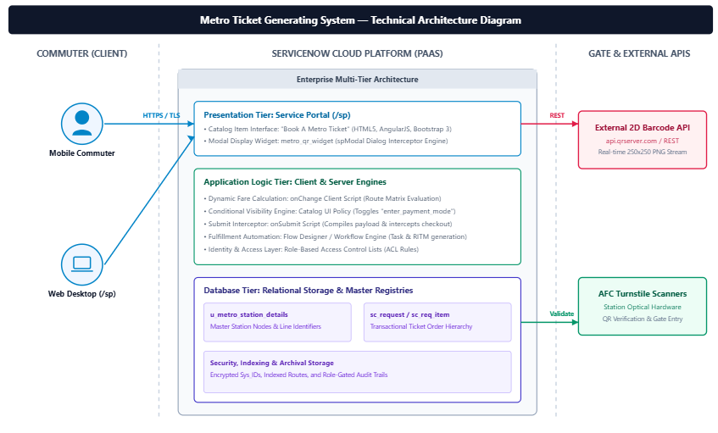

Table-1 : Components & Technologies:
S.No | Component | Description | Technology
1. | User Interface | Web and mobile portal interface where commuters select stations, choose passenger counts, view dynamic fares, and inspect the generated QR pass. | HTML5, CSS3, JavaScript, AngularJS, Bootstrap 3 (ServiceNow Service Portal framework)
2. | Application Logic-1 | Client-side dynamic fare computation matrix calculating single and return journey charges in real time upon route change. | JavaScript (ES5 / ES6), ServiceNow Catalog Client Script (onChange)
3. | Application Logic-2 | Conditional UI Policy engine that shows and mandates alternate payment fields when "Others" is selected. | ServiceNow Catalog UI Policy & UI Policy Actions
4. | Application Logic-3 | Submit interception engine that constructs the encoded payload, triggers ticket generation, and renders an interactive popup. | JavaScript, ServiceNow spModal API, Custom Portal Widget (metro_qr_widget)
5. | Database | Custom relational table storing station nodes, unique station abbreviations, and operational availability states. | ServiceNow Relational Database Schema (u_metro_station_details)
6. | Cloud Database | Cloud transactional storage tracking metro order fulfillment, passenger counts, generated sys_ids, and request items. | ServiceNow Cloud Backend Database (sc_request, sc_req_item)
7. | File Storage | Ephemeral storage and caching of the generated 250x250 scannable 2D barcode passes and portal widget assets. | ServiceNow Attachment Repository & Browser Cache / Blob Storage
8. | External API-1 | Public REST endpoint for dynamic 2D barcode generation using encoded ticket parameters and unique sys_id tokens. | External QR Server API ([https://api.qrserver.com/v1/create-qr-code/](https://api.qrserver.com/v1/create-qr-code/))
9. | External API-2 | Identity verification interface for passenger validation and digital concession verification. | Government Identity Verification API / National ID Concession Interface
10. | Machine Learning Model | Predictive route and crowd density model forecasting peak station usage and optimal train dispatch schedules. | ServiceNow Predictive Intelligence / Transit Demand Forecasting Model
11. | Infrastructure (Server / Cloud) | Enterprise multi-instance cloud environment running the ServiceNow platform with automated scaling and daily backups. | Cloud Infrastructure: ServiceNow Advanced High Availability (AHA) Cloud Architecture

Table-2: Application Characteristics:
S.No | Characteristics | Description | Technology
1. | Open-Source Frameworks | Responsive client-side MVC framework and grid styling libraries powering the Service Portal and widget templates. | AngularJS 1.5.x, Bootstrap 3.3.x, FontAwesome Icons
2. | Security Implementations | Role-based Access Control Lists (ACLs) restricting write access to metro_admin, TLS 1.3 encryption in transit, and sys_id tokenization. | ServiceNow Contextual Security (ACLs), TLS 1.3 HTTPS, SHA-256 Payload Tokenization
3. | Scalable Architecture | Tiered multi-instance cloud model separating user interface, application script logic, and database clusters. | 3-Tier Enterprise Cloud Architecture (Presentation, Logic Engine, Relational DB)
4. | Availability | Continuous system operation across redundant geographical cloud availability zones ensuring uninterrupted commuter access. | ServiceNow High Availability Pair (Dual Data Center Redundancy & Automated Failover)
5. | Performance | Sub-200ms client-side script execution for fare calculation, edge-cached UI styling, and asynchronous image retrieval. | Client-side Caching, Asynchronous REST API Calls, Optimized Indexed Database Queries

